Lab report 2: phonon calculation of bulk Si and AlAs

1. Exercise one
2. Calculate total energy of bulk Si and report energy

si.scf.out

total energy = -15.85438131 Ry

1. Calculate Gamma point phonon frequency of bulk Si and report phonon frequency at Gamma

si.phG.out

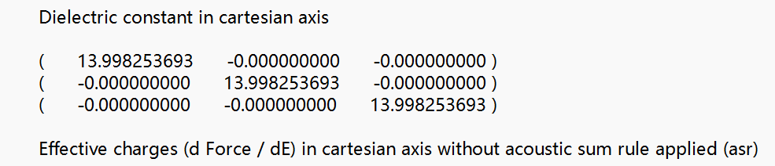

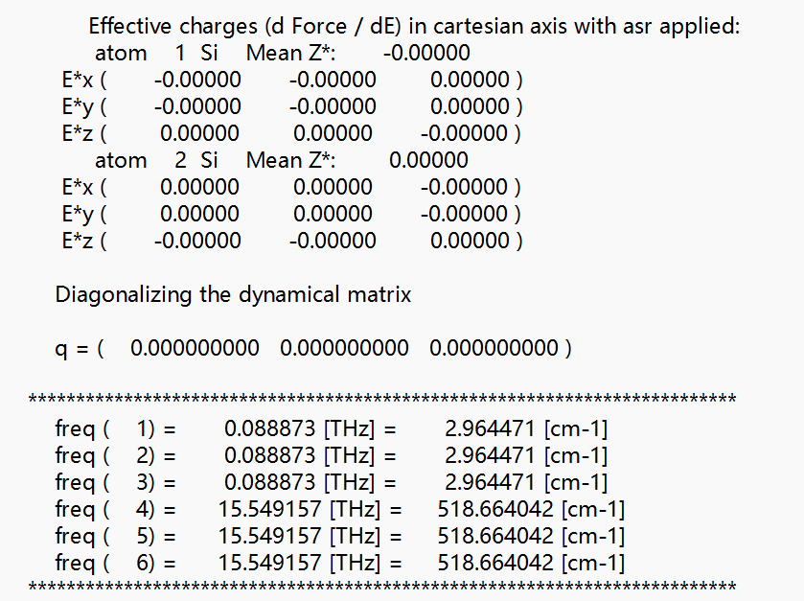

dyn.G

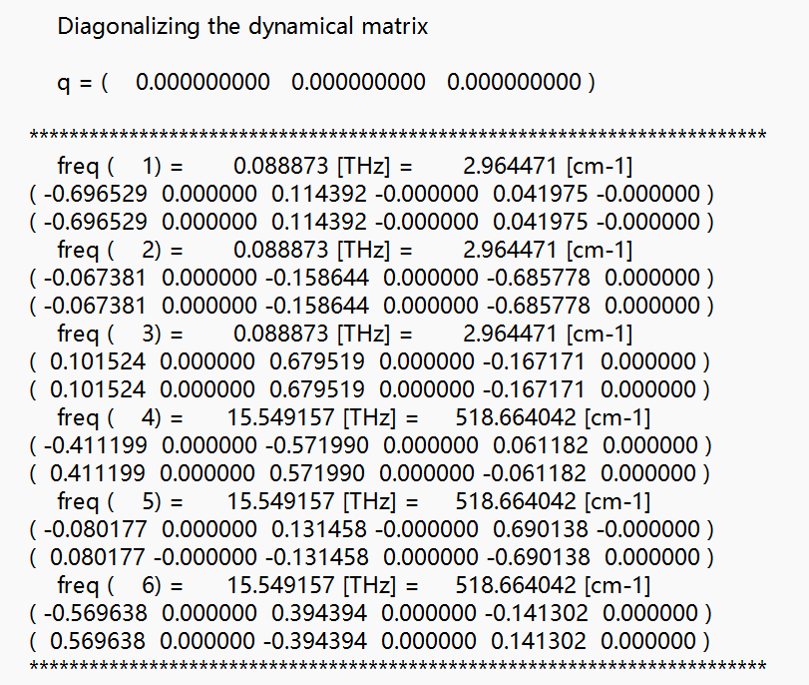

1. Exercise two
2. Calculate total energy of AlAs and report energy

alas.scf.out

total energy = -16.98632170 Ry

1. Calculate Gamma point phonon frequency of AlAs and report phonon frequency at Gamma

alas.phG.out

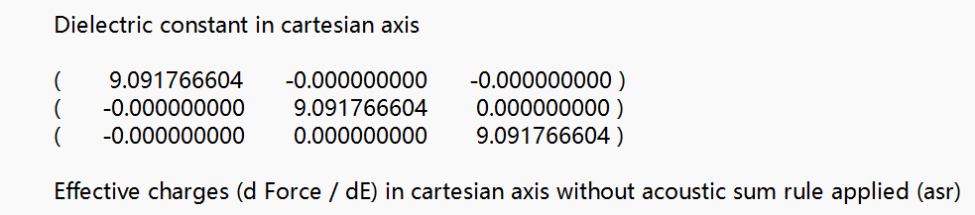

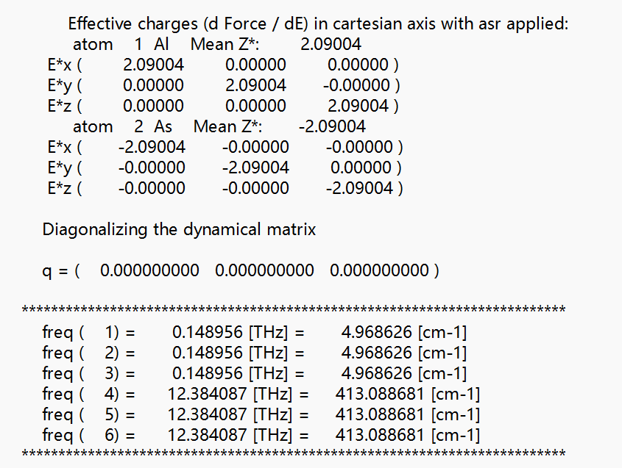

dyn.G

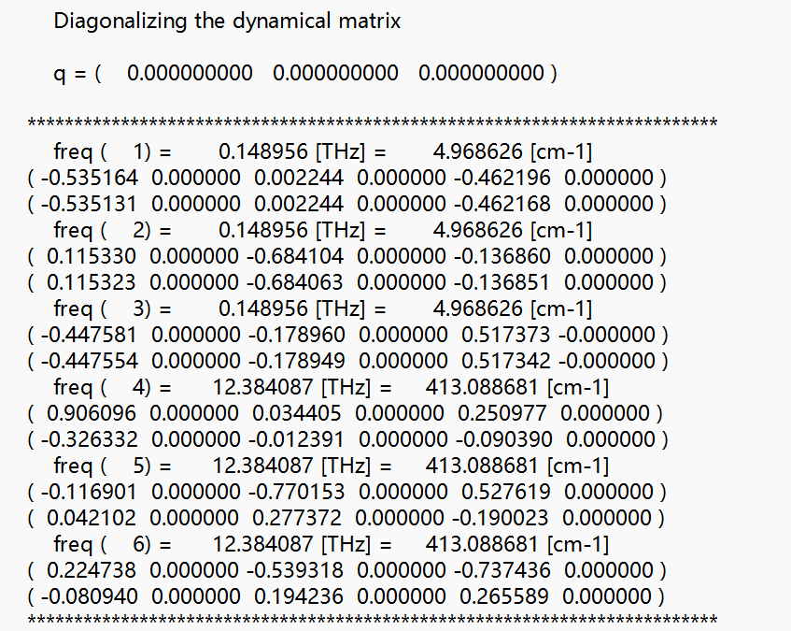

1. Apply Acoustic sum rule and LO-TO splitting then report phonon frequency at Gamma

alas.dynmat.out

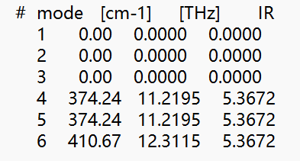

1. Exercise three (Bulk Si)
2. Calculate phonon frequency at uniform grid 4x4x4

si.freq

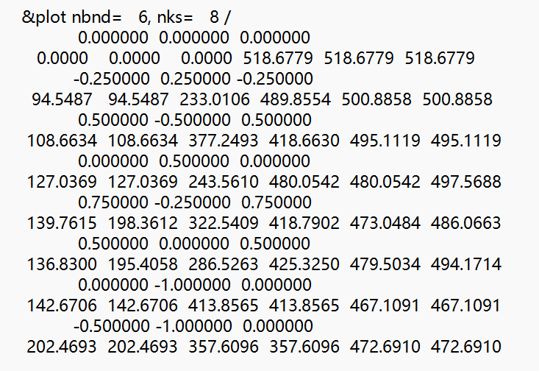

1. Calculate phonon dispersion and plot phonon dispersion

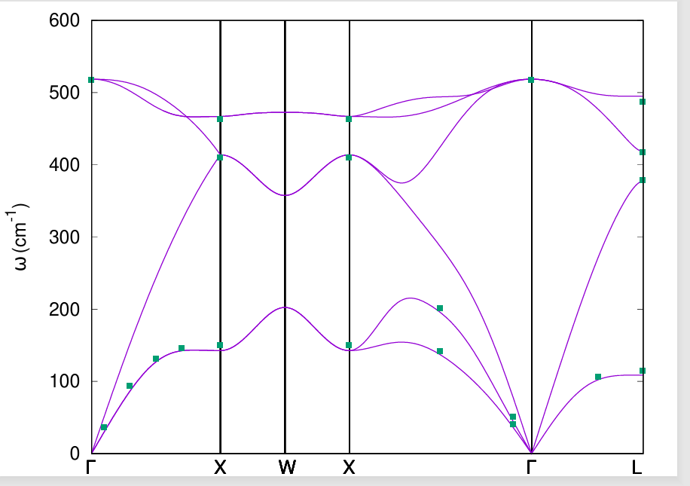

1. Calculate phonon density of states and plot phonon density of states

